# SQL Assignment - 6

**Q1. Display the system date.**

**Ans1. select to_date(sysdate) as SYSTEM_DATE from dual;**

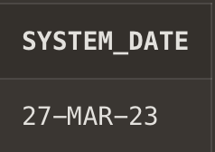

**Q2. Display current day.**

**Ans2. select to_date(current_date) from dual;**

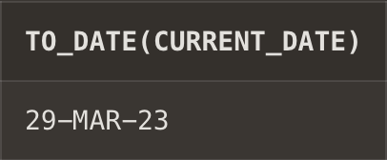

**Q3. Display current month and spell out year.**

**Ans3. select to_char(sysdate, 'Month') from dual.**

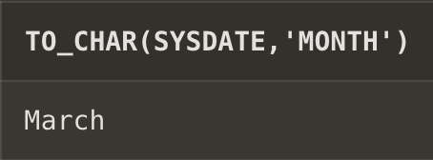

**Q4. Display spell out current date.**

**Ans4. select to_char(sysdate,'MONTH DD YYYY') "Today" from dual;**

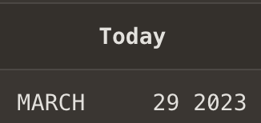

**Q5. Check whether it is AM or PM right now**

**Ans5. select to_char(time '1:16:21','am') from dual;**

**select to_char(time '13:16:21','am') from dual;**

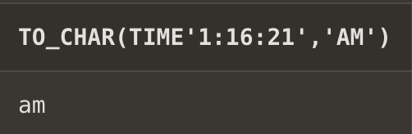 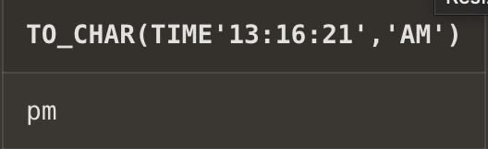

**Q6. Display the date of next Friday.**

**Ans6. select to_date(current_date) as today,to_date(current_date+2) as nextfriday from dual;**

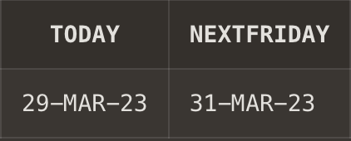

**Q7. Round the system date on month.**

**Ans7. select round(to_date(current_date),'MONTH') from dual;**

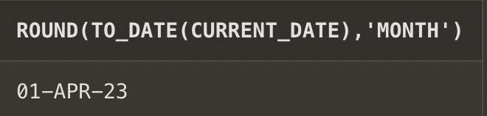

**Q8. Truncate the system date on month.**

**Ans8. select trunc(to_date(sysdate),'MONTH') from dual;**

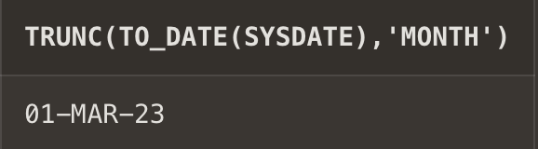

**Q9.** **Round the system date on month.**

**Ans9. select round(to_date(sysdate),'year') from dual;**

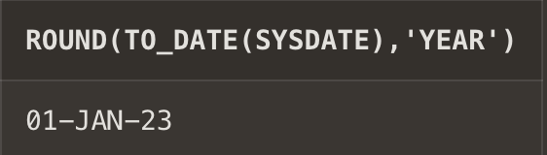

**Q10. Truncate the system date on year.**

**Ans10. select trunc(to_date(sysdate),'year') from dual;**

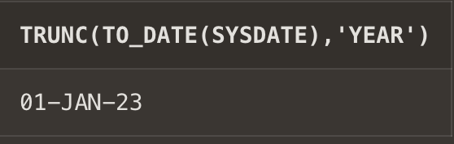

**Q11. Find the day after three days.**

**Ans11.select to_char(to_date(current_date),'Day')as "present day",to_char(to_date(current_date+3),'Day') as "Day after 3 days" from dual;**

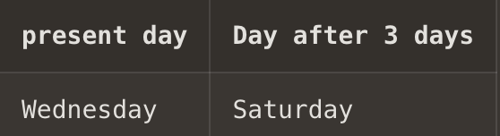

**Given Table:-**

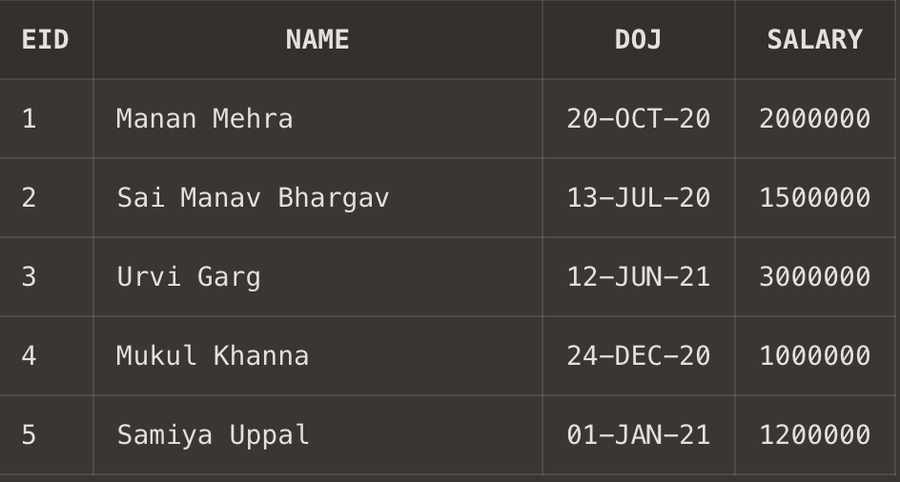

**Q12. Display day of date of joining column.**

**Ans12. select to_char(DOJ,'DAY') from employee;**

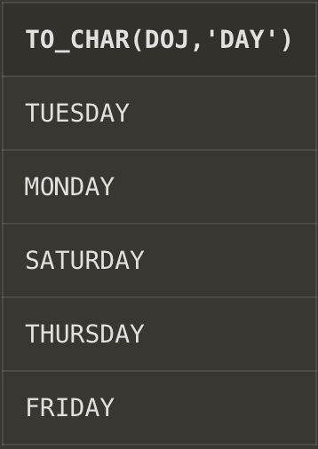

**Q13. Display those employees who join the company on Monday.**

**Ans13. select Name from employee where trim(to_char(DOJ,'DAY'))='Monday';**

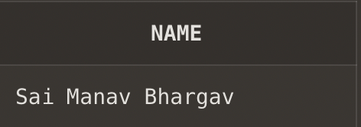

**Q14. Display those employees who join the company this month.**

**Ans14. select Name from employee where to_char(DOJ,'MONTH')=to_char(sysdate,'MONTH');**

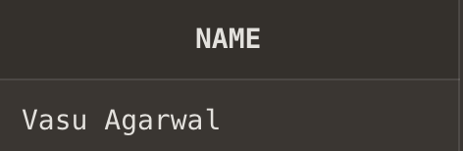

**Q15. Display those employees who join the company in last 30 days**

**Ans15. select * from employee where DOJ between sysdate-30 and sysdate;**

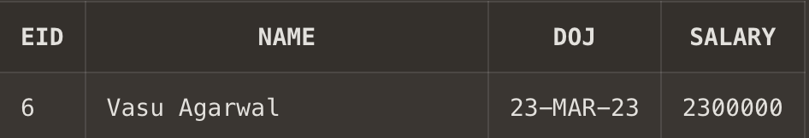

**Q16.** **Train Number, date of Departure, time of departure, time of arrival**

**Ans16.** **create table train(TID int,DateOfDeparture date,TimeofDeparture timestamp,TimeOfArrival timestamp);**

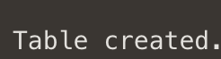

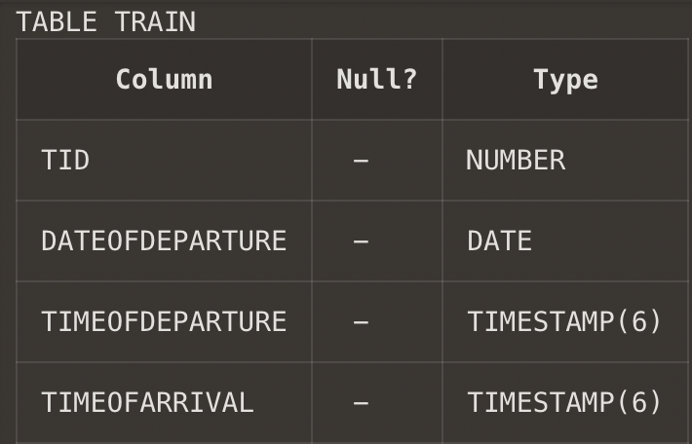

**Q17. Insert five columns in train table**

**Ans17. insert into train values (101, "22-FEB-2022 10:00:00", "22-FEB-2022 13:30:00");**

**insert into train values (102, "22-FEB-2022 12:00:00", "22-FEB-2022 15:45:00");**

**insert into train values (103, "01-OCT-2021 09:30:00", "01-OCT-2021 12:45:00");**

**insert into train values (104, "10-SEP-2021 11:00:00", "10-SEP-2021 14:15:00");**

**insert into train values (105, "02-JAN-2023 15:30:00", "02-JAN-2023 18:45:00");**

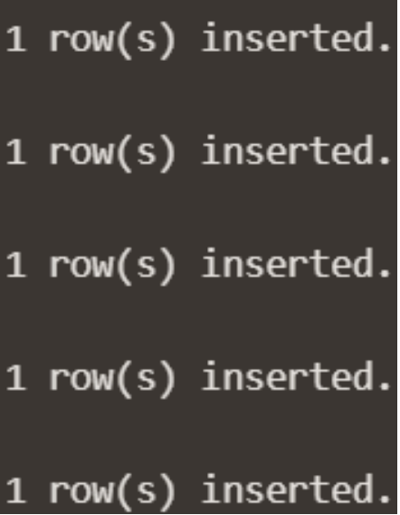

**Q18. Display all the records.**

**Ans18. select * from train;**

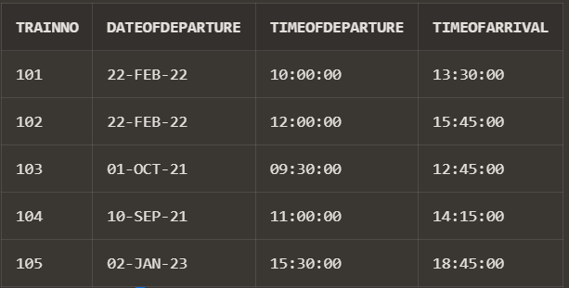

**Q19. Display the time values inserted in the columns.**

**Ans19. select TimeOfArrival, TimeOfDeparture from train;**

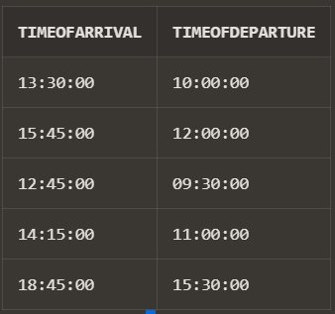

**Q20. Display those trains which arrived on PM.**

**Ans20. select arrival_time from train where (to_char(arrival_time,'pm')='pm');**

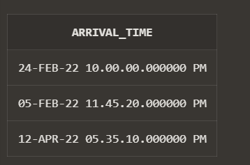

**Q21. Display train number who are going to depart in next one hour.**

**Ans21. select TID from train as TRAIN-NO where departure_time between timestamp'2022-02-05 23:30:00.00' and timestamp '2022-02-06 00:30:00.00';**

